**Team RGB:**

A Quick Look at the Financial Statements of 3 American chipmakers

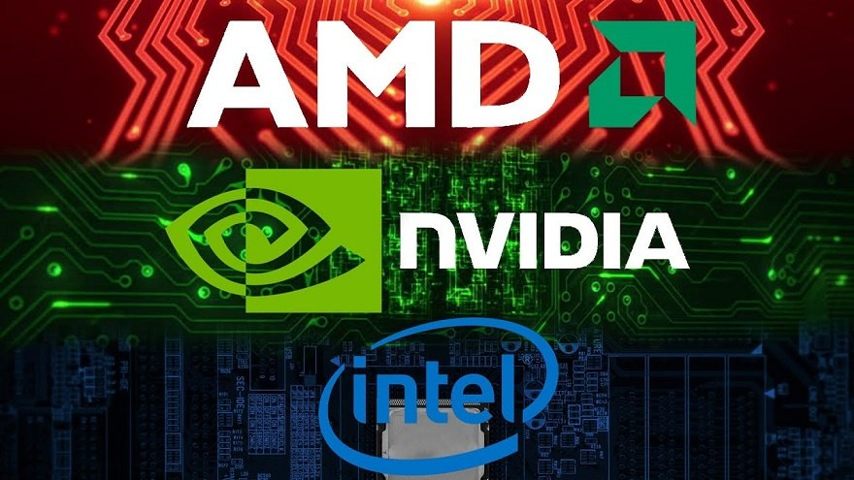

**July 2021**

**Introduction**

Advanced Micro Devices (AMD), Nvidia, and Intel are among the biggest semiconductor/chip-manufacturing companies in the world. All based in Silicon Valley (pun intended), these businesses make products that are present in almost every class of electronics we use today. From powerful gaming GPUs to bleeding-edge AI accelerators to innovative rendering technologies and more, they are all key to making 21st century technology what it is today.

But despite the enormous value that these companies provide to consumers & professionals alike, it is quite evident that the COVID-19 pandemic and a turbulent 2020 caused a massive chip shortage. With supply chains disrupted across the globe, these three companies (among many others) have taken a noticeable financial hit. Demand has skyrocketed across the board with supply struggling to catch up even as economies everywhere return to some sense of normalcy. The transition to working from home and the historic cryptocurrency surge are just some of the factors that lead to the ongoing supply squeeze, resulting in even the auto industry to feel some pain.

This short document will look at the three major financial statements for AMD, Nvidia, and Intel to get a basic understanding of their position and see which among them *might* be a good investment.

*Disclaimer: This is not meant to be any kind of financial advice. I am not an accountant or advisor and merely going through historical data scraped from MacroTrends****1****.*

**Balance Sheet**

Intel has the most cash on hand by far, coming in at just under $22.4 billion as of Q1 2021, with Nvidia and AMD coming in 2nd and 3rd at $11.5 billion & $3.1 billion respectively.

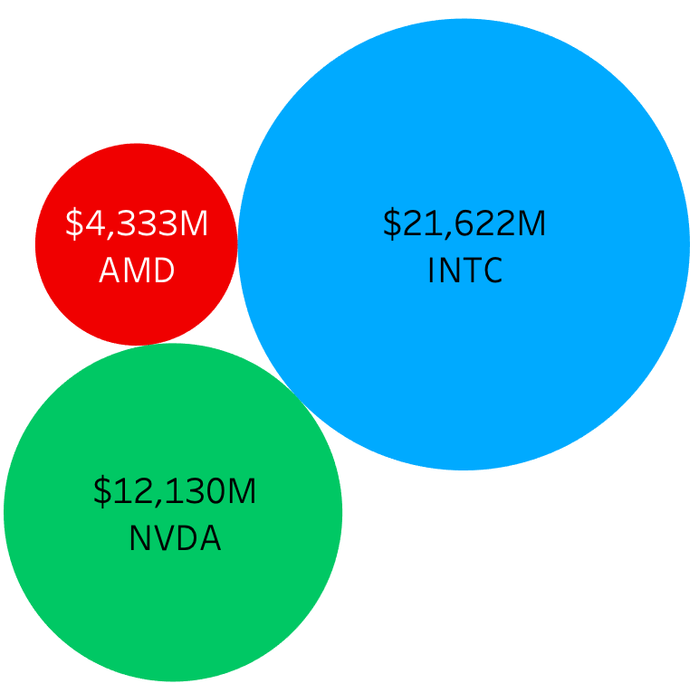

*Figure 1: Working Capital – (Q1 2021)*

All three companies obtained a current ratio well above 1.0, indicating a strong capacity to pay their short-term liabilities within 12 months. From a shareholder’s perspective, all 3 companies had massive Debt-to-Equity ratios during the middle of last year --- understandable given the pandemic. Both AMD and Nvidia seemed to recover Q4 onwards, with AMD being the only company with current liabilities consistently higher than its long-term liabilities. However, Intel may be a cause for concern in this regard as it continues to be highly leveraged with values above 0.8.

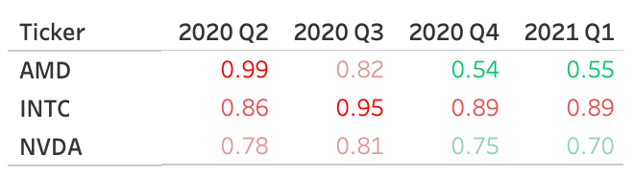

*Figure 2: Debt-To-Equity Ratio Last 4 Quarters*

**Income Statement**

When it comes to top-line revenue, Intel leads the pack yet again by far, pulling in over $19.6 billion despite a slight year-over-year decrease of 0.78%. In fact, Intel is the largest semiconductor company in the world according to revenue2. The first quarter of 2021 reveals that among the three companies, Nvidia paid the smallest portion of its pre-tax income in taxes (0.95%) and had the smallest Cost of Goods Sold as a percentage of revenue (36.8%).

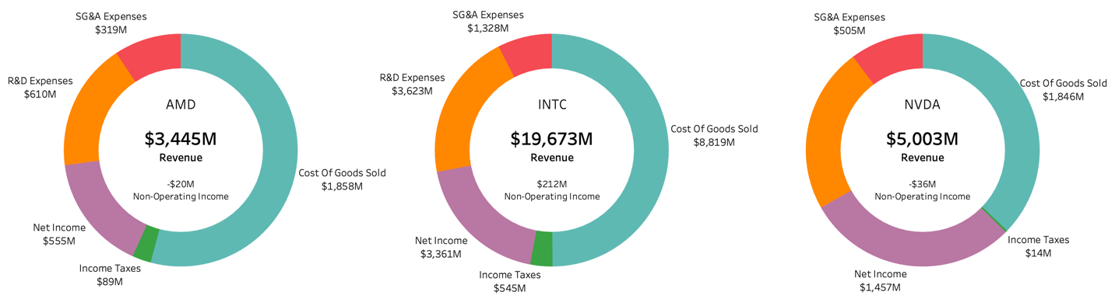

*Figure 3: Expenses – Most recent quarter*

Figure 3 reveals that AMD consistently operates on the slimmest of margins, save for the massive uptick in Q4 2020, whereas Nvidia & Intel operate on margins around 20-30%. All the companies did see noticeable upticks in revenue in Q4 likely attributable to the holiday season/sales. AMD observed $3.2 billion in revenue that period --- a massive 52% increase year-over-year! In this timeframe, Nvidia released their RTX-3000 series GPUs while AMD released both their Ryzen 5000 series CPUs & RX 6000 series GPUs, all of which were heavy in consumer demand and consistently sold out among retailers.

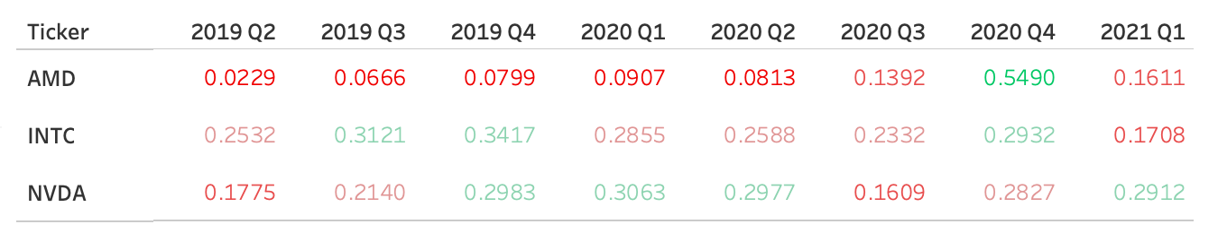

*Figure 3: Net Profit Margin*

**Cash Flow Statement**

As indicated by the chart below, AMD is the only company that is cash flow positive as of the most recent quarter. Everyone took a big hit during the latter half of 2020, with Nvidia having by far the biggest loss in Q3 of over $10 billion.

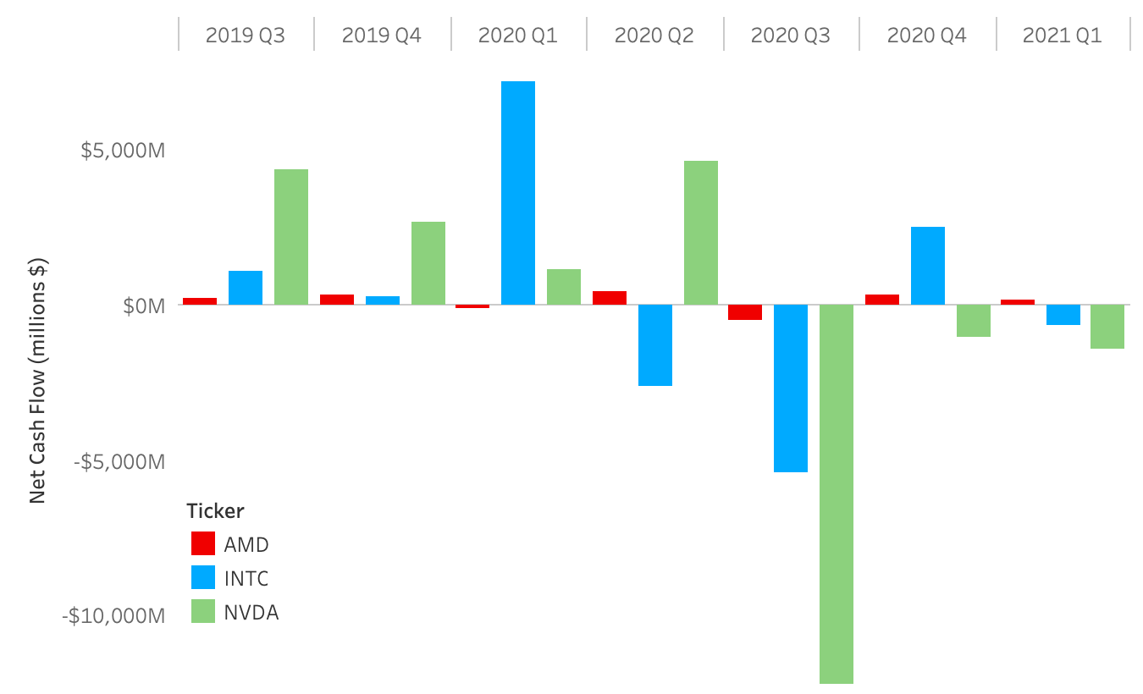

*Figure 5: Net Cash Flow*

On the topic of dividends, AMD is still the only of the 3 companies to not pay out a dividend to its shareholders. Nvidia has paid out dividends of just under $100 million per quarter for the past 2 years, whereas Intel has paid out roughly $1.4 billion per quarter for the same time period. While it’s a benefit to investors as an incentive to invest in the two companies, at the end of the day, it is still cash coming out of the companies’ pockets that *could* have been used to invest elsewhere to boost their supply chains.

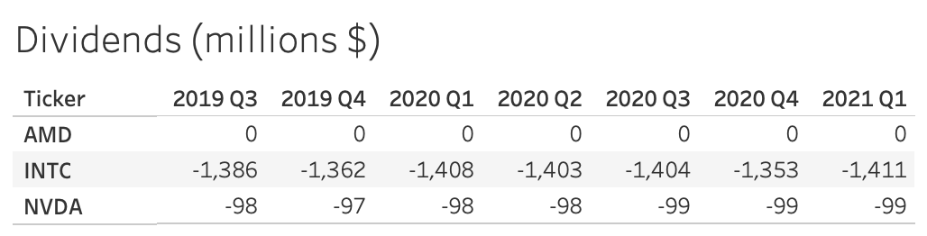

*Figure 6: Dividends Paid*

**Conclusion**

When it comes to investing in one of the three companies discussed here, it is my opinion that AMD would be the best choice. Intel’s revenue growth has remained relatively stagnant – up

22% from Q1 2019 to Q1 2021 vs. 170% and 150% for AMD & Nvidia respectively. All this despite Intel dwarfing the other two in terms of money to work with across the business. Add this to the reality that Intel is losing ground in desktop CPU market share. One major factor to this was Apple’s decision in 2020 to transition all of the chips across their Mac lineup away from Intel’s offerings towards in-house Apple silicon. Another potential reason for the decline could be the availability of a viable competitor in AMD through the eyes of the consumer.

That is to say, Nvidia has some solid fundamentals too. First of all, Nvidia is in the best position to handle its short-term obligations with a current ratio over 4.0. Additionally, Nvidia has demonstrated high profitability & good margins, including the best book value per share among the three companies of $30. Ultimately though, the average investor may be priced out of Nvidia, as it closed at almost $820 per share as of July 2, 2021.

Although AMD has only recently shown signs of profitability, their product releases within the past 2 years show significant promise in long-term gains for the stock. There are many compelling chips on both the CPU and GPU side of things that appear to be the best bang-for-buck value, despite trading blows with Intel’s chips for the performance crown. Despite getting trounced in market share for mobile & server computing chips, AMD has notched a roughly 51% lead in the desktop market as of January 2021 – the first time this has happened since 20064.

**References**

1. <https://www.macrotrends.net/>

* Data used in this report was scraped from here

1. <https://www.zippia.com/advice/largest-semiconductor-companies-world/>

* Semiconductor company rankings

1. <https://www.tomshardware.com/news/jpr-gpu-shipments-in-q1-2021-hit-119-million-units>

* Discrete GPU market-share article

1. <https://www.techradar.com/news/amd-overtakes-intel-in-desktop-cpu-market-share-for-the-first-time-in-15-years>

* Desktop CPU market-share article

1. <https://public.tableau.com/app/profile/aniruddha823/viz/TeamRGB/TeamRGBTiled>

* Tableau dashboard with some of the graphics used here

1. <https://github.com/aniruddha823/teamRGB>

* Repository containing the Jupyter Notebook used to scrape the data & the data itself in CSV format